**Programming Assignment 4 – Chapter 9**

**Instructions**

**a.**

Implement a class Car with the following properties. A car has a certain fuel efficiency (measured in miles/gallon) and a certain amount of fuel in the gas tank. The efficiency is specified in the constructor, and the initial fuel level is 0. Supply a method drive that simulates driving the car for a certain distance, reducing the fuel level in the gas tank, and methods getGasLevel, to return the current fuel level, and addGas, to tank up. Sample usage:

myHybrid = Car(50)   # 50 miles per gallon  
myHybrid.addGas(20)   # Tank 20 gallons  
myHybrid.drive(100)   # Drive 100 miles  
print(myHybrid.getGasLevel())   # Print fuel remaining

Sample Output

18.0

>>>

**Code**

**PA_Car.py**

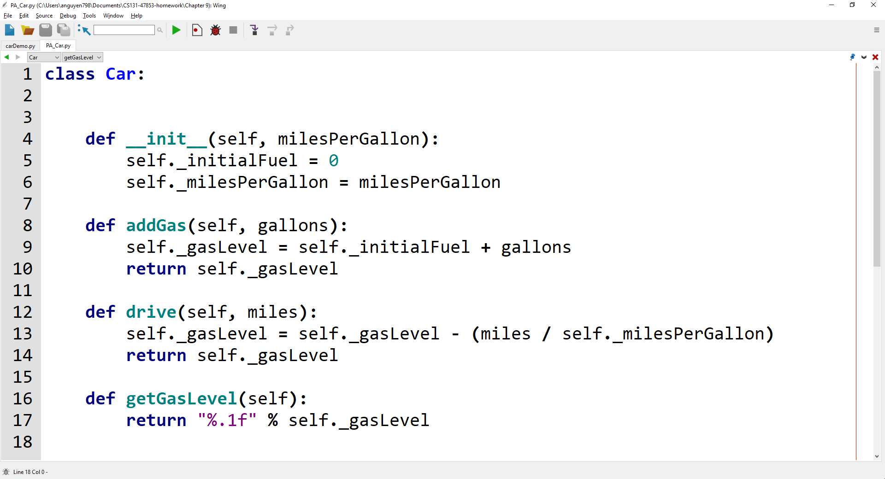

**carDemo.py (import PA_Car.py Car class)**

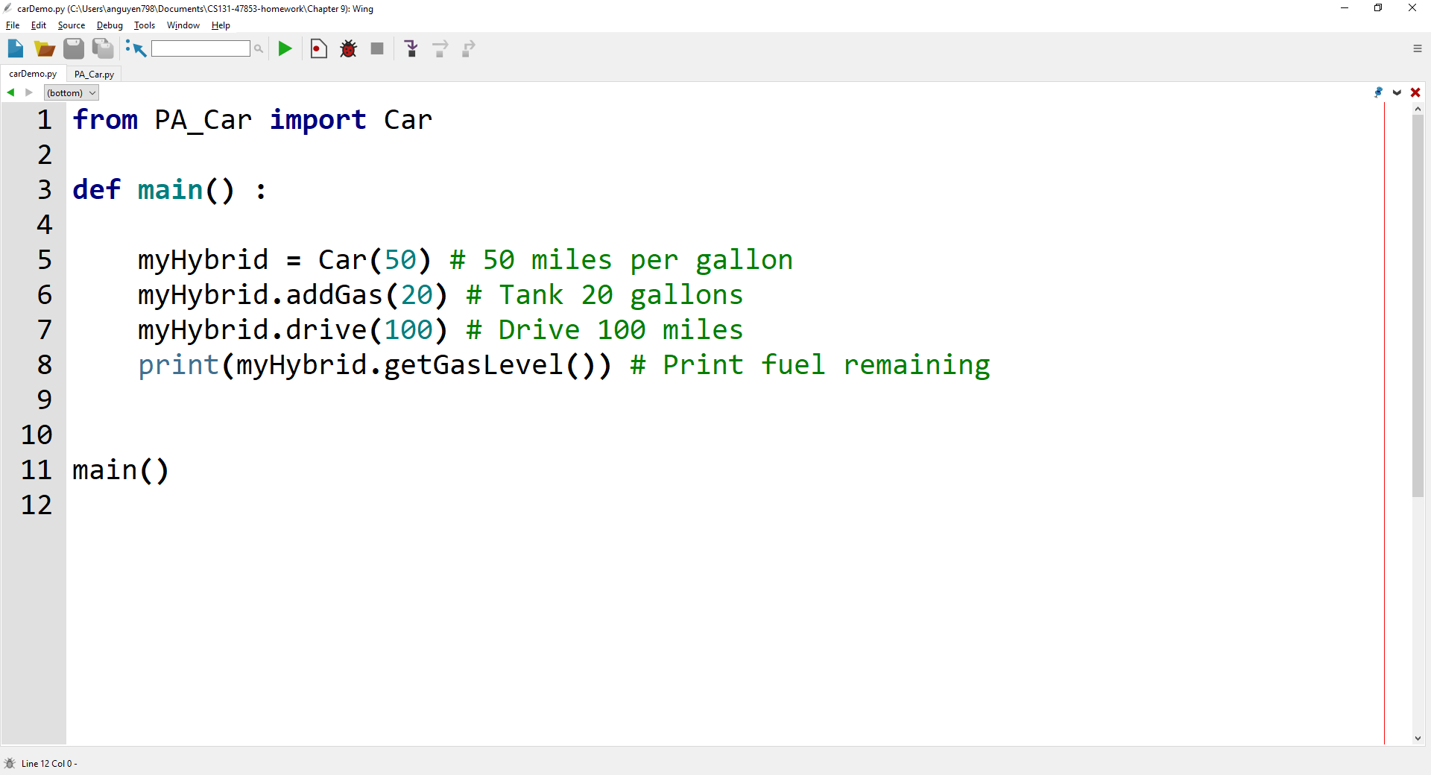

**Output**

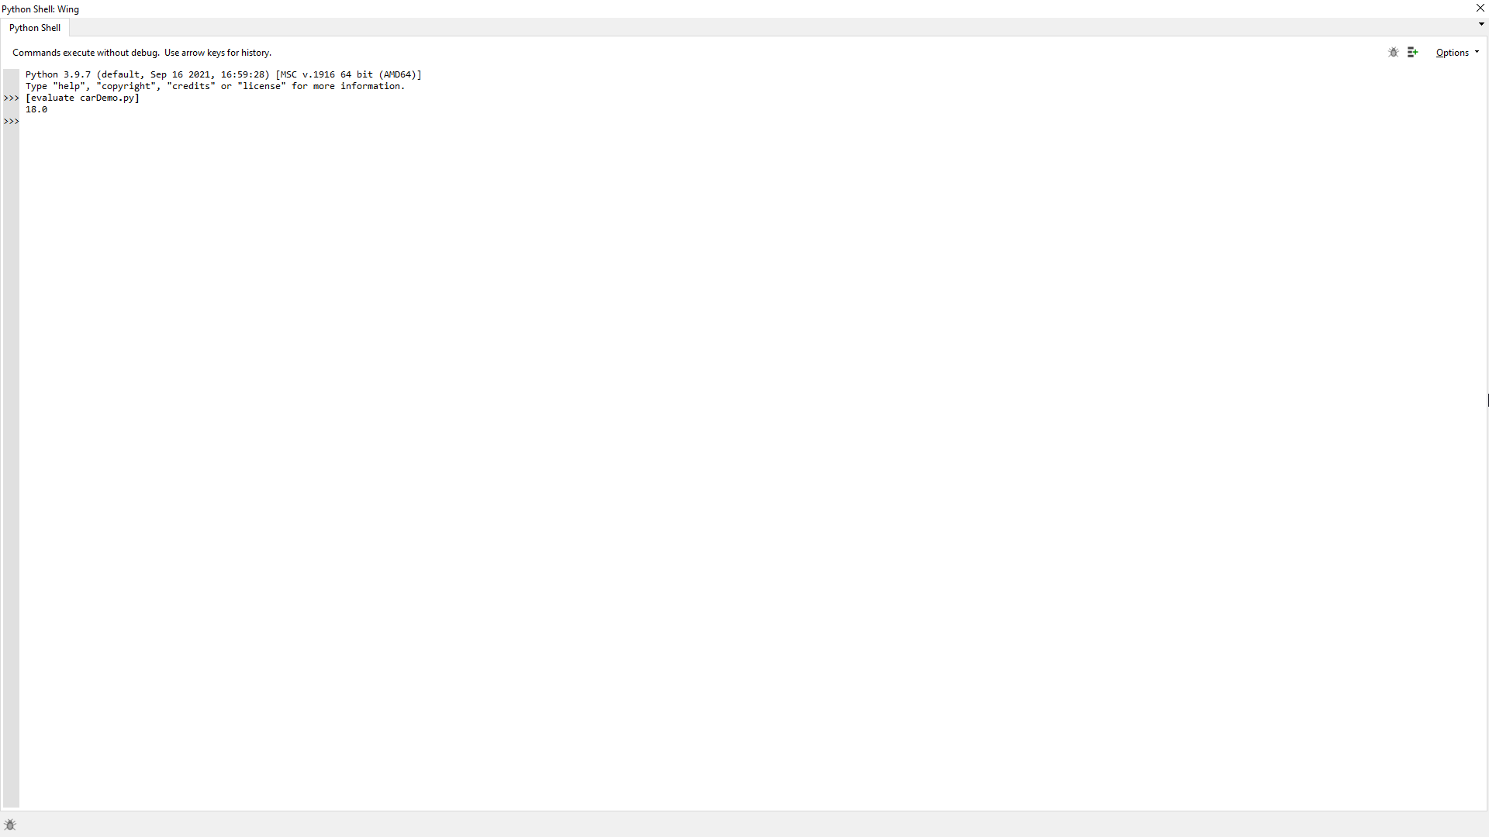

**Lab 9 – Written Code**

**PA_Car.py**

class Car:

    def __init__(self, milesPerGallon):

        self._initialFuel = 0

        self._milesPerGallon = milesPerGallon

    def addGas(self, gallons):

        self._gasLevel = self._initialFuel + gallons

        return self._gasLevel

    def drive(self, miles):

        self._gasLevel = self._gasLevel - (miles / self._milesPerGallon)

        return self._gasLevel

    def getGasLevel(self):

        return "%.1f" % self._gasLevel

**carDemo.py**

from PA_Car import Car

def main() :

    myHybrid = Car(50) # 50 miles per gallon

    myHybrid.addGas(20) # Tank 20 gallons

    myHybrid.drive(100) # Drive 100 miles

    print(myHybrid.getGasLevel()) # Print fuel remaining

main()